Doorstep Banking (DSB) Services through PSB Alliance
The Doorstep banking services are being provided to all resident Indian customers (Individual Segment) having KYC compliant accounts and registered mobile numbers with the bank (except minors and illiterates) through PSB Alliance Channel:
- SERVICES AVAILABLE: Following services are available under PSB Alliance Doorstep banking

- Pick up Services  (From Customer and deliver to Branch) |  | - Delivery Services  (Pick up from Branch and deliver to Customer)
Add/Edit/Cancel Nominee Form |  | Delivery of Pay Orders
Cheque Book Requisition Slip |  | Demand Draft
Fund Transfer |  | Non-Personalised Cheque Book
GST Challan |  | Prepaid Instrument/Gift card
IT Challan |  | Request for Account Statement
Pickup Cheque /PO/DD |  | Small Savings Scheme Account Opening Form
Standing Instructions |  | TDS/Form16 Certificate
15G /15H Forms |  | Term Deposit Receipt
C) Financial Services |  | D) Special Services
Cash Withdrawal using Aadhaar /Debit Card |  | Digital Life Certificate submission

- Doorstep Banking Services are available to all individual customers except as under:
- Joint Accounts operated jointly, Former /Survivor and Later /Survivor
- Minors’ Accounts including under Guardianship
- Accounts operated through Power of Attorney
- Non-KYC compliant Accounts & Inoperative Accounts.
- Savings Bank Accounts opened under MACT Claims / LISSA
- NRI / Foreign National Account holder
- Non-Individual Customers like Trust, HUF, Associations etc.
- Accounts having status as Stop and/or Hold
- Illiterate Customers

- HOW TO AVAIL DOORSTEP BANKING (DSB) SERVICES
Customers can book Doorstep service request via any of the following touch points:
- Mobile Application: Can be downloaded from Google Play Store App Store | 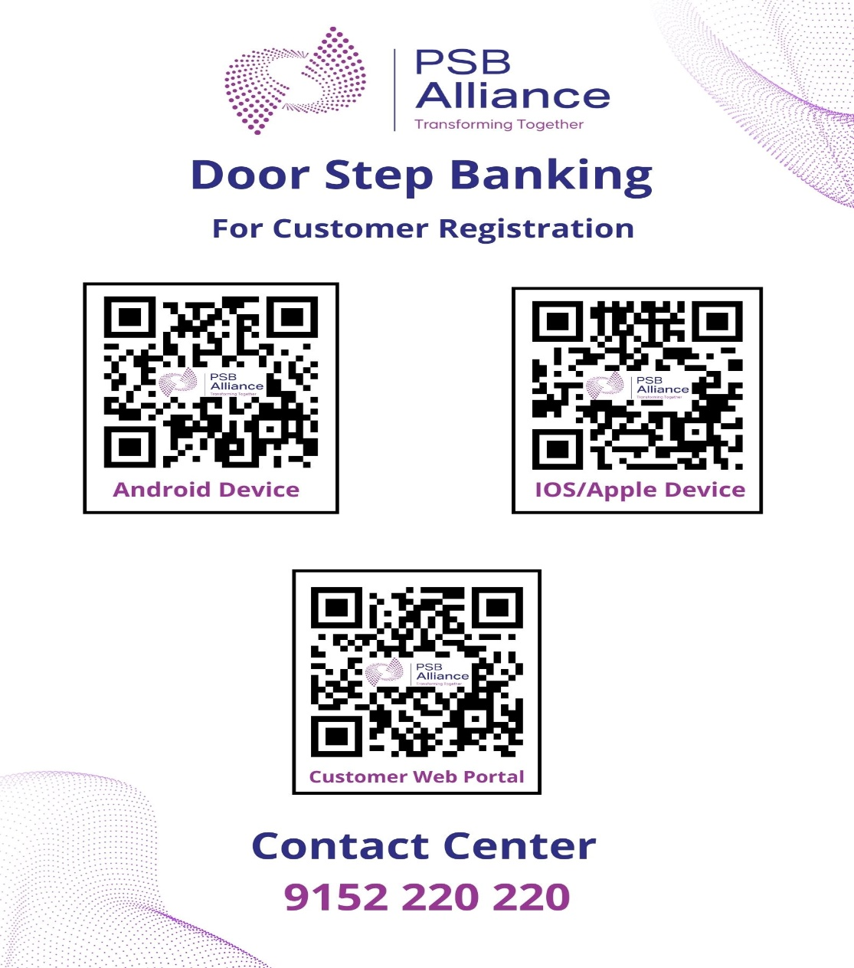   | 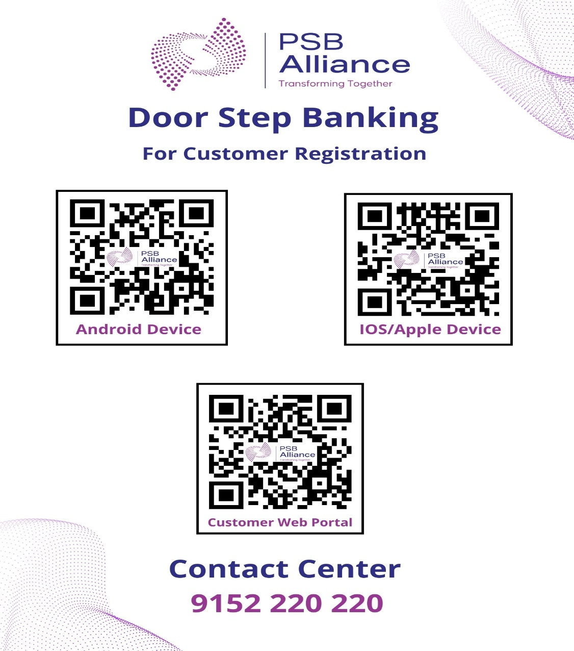  
- Web Portal: Can be accessed at | 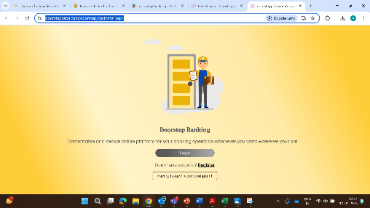  https://www.doorsteppsba.com/doorstep/customerlogin | 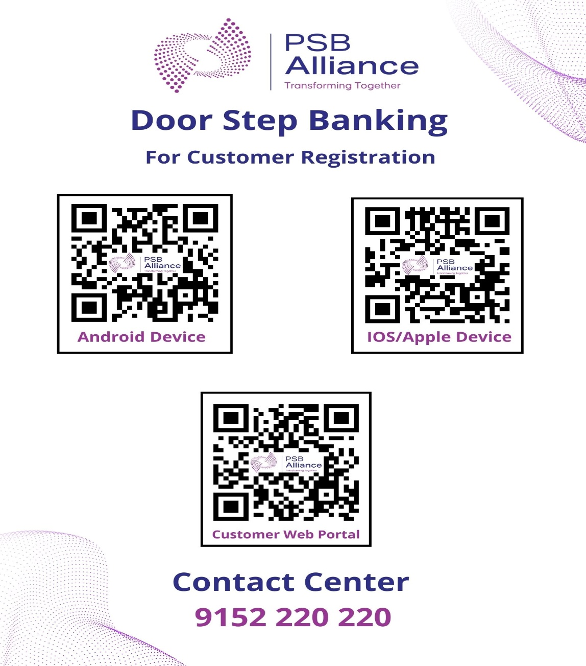
- Contact Center: by calling | 9152220220 | 83022266622

SERVICE HOURS: Services register up to 3 PM on any working day have to be completed within 3 hours of request. Services booked after 3 PM shall be completed by 1 PM of next working day.

- SERVICE CHARGES #:
Service Description | Cost Per Call / Service
Financial/ Non-Financial Services # | Rs 75/- + GST 13.500 = Rs. 88.50
Calls made to Call Centre for enquiry purpose (Where Agent for service delivery is not required) | No Charge
Doorstep Banking Services would be provided to customers on chargeable basis, the present rates being as follows:
# Doorstep Banking Facility to Divyangjans is free of cost up to 3 transactions per month
- Customer shall not make any payment for the services to the Agent.
- TRACKING SERVICE REQUEST RAISED:
Customers can track the status of service request in Doorstep Banking App / Web Portal with following details: Status Request ID, Request type, Agent name, Charges, SR status. Agents will be assigned as per availability and up to 30 Mins prior to preferred time slot of service request.

- CANCELLATION OF SERVICE REQUEST:
Customer can cancel an active service request as under:
- In case of Pickup Service, Service request cancellation is allowed before agent pick up the document from customer.
- In case of Delivery Service, Service request cancellation is allowed before bank user completes the request.

- GRIEVANCE REDRESSAL:
Customer can register his complaint regarding Doorstep Banking Services through Mobile App/ Web Portal / Call Centre (details as per Para B above) or through Branch.
- OTHER IMPORTANT INSTRUCTIONS:
- Doorstep Service shall be provided for in customer’s own account only.
- Multiple instruments can be picked by an agent for single pick-up request. However, different instrument types cannot be clubbed for a single request ID.
Pick up Request | Instrument/ details to be captured | No of Instrument/ Document / Amount allowed
Cheque / DD / PO | Beneficiary, Number of Instrument | Maximum 5 Instruments
IT /GST CHALLAN | IT Challan and Beneficiary Cheque | One document
SI | Number of Instrument | One Application
Cheque Book Requisition Slip | Number of Instrument | One request
15G/H | NA | One Application
Fund Transfer | Request letter, Transfer Cheque | One request
Delivery Request | Instrument/ details to be captured | No of Instrument/ Document / Amount allowed
TD Receipt | Amount (Entry Field) | Maximum Amt. 50,000
TDS | Beneficiary (Auto populated)
DD | Beneficiary, Number of  Instrument (Entry Field) | Max 5 Instrument
Gift Card | Amount (Entry Field) | Max amt 10000
Account statement | From date, To date (Entry  Field) | Max 3 month
Pay Order | Beneficiary, Number of  Instrument (Entry Field) | Max 5 Instrument

- Customer shall not provide any stale/ mutilated/ tampered/ defective cheque/ instruments to the Agent. SBI is not liable for not crediting any such amount of the total value of the stale/mutilated/tampered/defective instruments in the Account of the Customer.

- The services shall not be available in Inoperative accounts and accounts which has been put on hold / freeze due to order of Govt Authority or otherwise.
- The customer shall attend Agent immediately on his arrival
- Keep sufficient balance in the account before placing of Doorstep Banking Service request.
- No other services /requests shall be entertained by Bank/ Agent other than the service request registered through Mobile App/ Web Portal/ Call Centre.
- Customer shall not share any detail/ information (e.g., Account No., Account Details, ATM Card/ PIN details etc.) with DSA.

Note:
The Doorstep Banking services should be seen only as an extension to regular banking services offered by our Bank and hence liability of the Bank shall remain same to the extent as if the transactions were conducted at the Branch.
The above operational instructions are for availing services under PSB Alliance Doorstep Banking Services.
Please refer below link to for PSB Alliance doorstep banking details : https://psballiance.com/doorstep-banking.html

