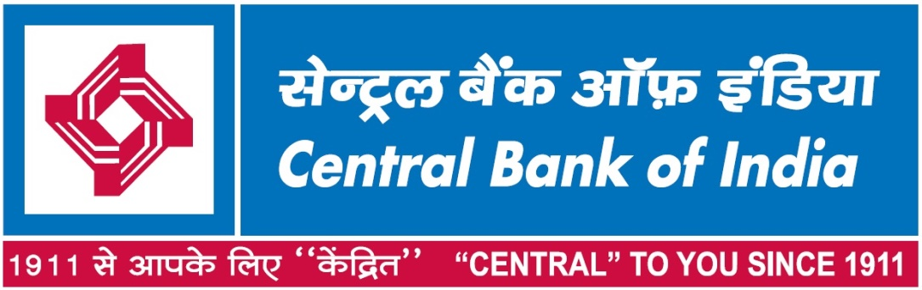

CORRIGENDUM FOR Tender No. RO/HYDE/GAD/18.11.2021

TENDER DOCUMENT

FOR

ANNUAL MAINTENANCE CONTRACT (AMC) OF ELECTRICAL INSTALLATIONS IN OFFICE BUILDING COMPLEX PREMISE AT BANK STREET, KOTI, HYDERABAD

RESCHEDULE OF PRE-BID MEETING

As per Original Tender Pre-bid Meeting schedule on 22.11.2021
Now the revised Pre-bid Meeting is on 29.11.2021 at 11:00 AM

