Execution of Service Level Agreement between Central Bank of India, CredAvenue Private Limited and Veefin Solutions Limited
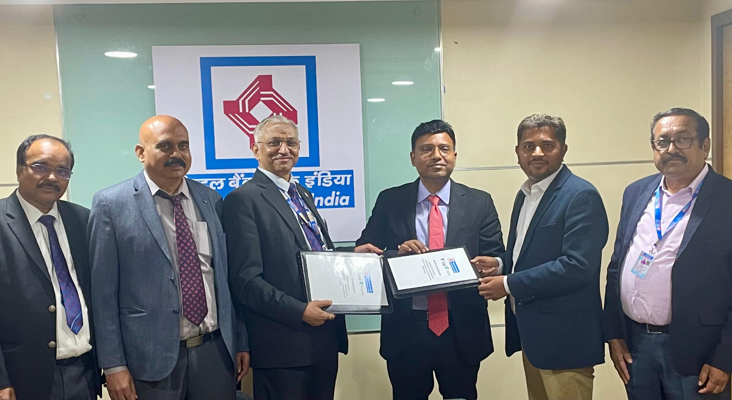
Central Bank of India has executed Service Level Agreement with CredAvenue Private Limited and Veefin Solutions Limited for implementation of Supply Chain Finance module in the bank.
Supply Chain Financing (SCF) is one of the options for extending short-term working capital finance to MSME and non MSME entities who are Dealers/Original Equipment Manufacturers / and Vendors (suppliers) and have business relationships with large Corporates or Mid Corporates including Government Departments and Public Sector Undertakings (“Anchors”). Similarly, Corporates also avail short term finance against these invoices for making payment to their Vendors and also for discounting of invoices against supplies made to their Dealers and Original Equipment Manufacturers.

Our Dealer/OEMs finance programme is for authorized Dealers and Original Equipment Manufacturers for purchase of inventory from large corporates.

Our Vendor Finance programme (Limit on Vendor) is for authorised vendors who are suppliers of Large Corporates.

Our Purchase Bill Discounting programme (Limit on Corporate) is for corporate entities having a Network of Dealers and Original Equipment Manufacturers & a large supplier’s base. The entire Journey of Limit sanctioning, Bills discounting and repayment is digitised.

MSMEs can approach for credit support under Supply Chain Finance module.

